User Acceptance Testing (UAT) Template
Date | 18 February 2026
Team ID | LTVIP2026TMIDS24292
Project Name | LearnHub : Your Center For Skill Enhancement
Maximum Marks | 10 Marks

Project Overview:
Project Name: LearnHub – Your Center for Skill Enhancement
Project Description: LearnHub is an online learning platform designed to help users enhance their skills through structured courses, assessments, and certifications. The platform allows users to register, log in, browse courses, enroll, learn at their own pace, and track progress efficiently.
Project Version: v1.0
Testing Period: 15-Feb-2026 to 18-Feb-2026
Testing Scope:
Features and Functionalities Tested:
- User Registration
- Email/Gmail Login
- User Authentication
- Dashboard Access
- Course Browsing
- Course Enrollment
- Learning Content Access
- Progress Tracking
User Stories / Requirements Tested:
- USN-1: User Registration
- USN-2: Email Confirmation
- USN-4: User Login
- USN-5: Dashboard Access
- USN-6: Browse Courses
- USN-7: Enroll in Course

Test Cases:
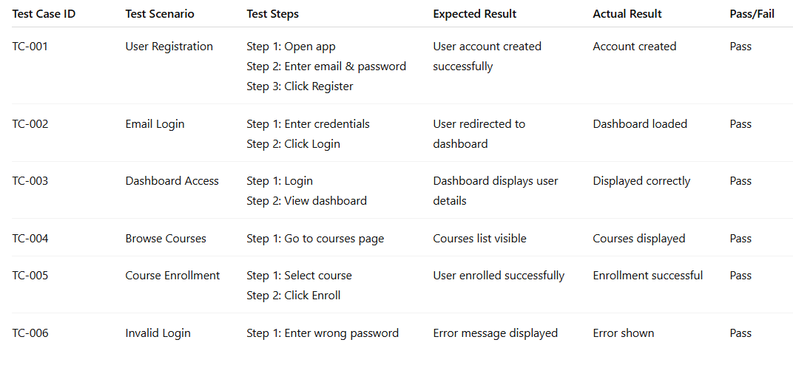
Bug Tracking:
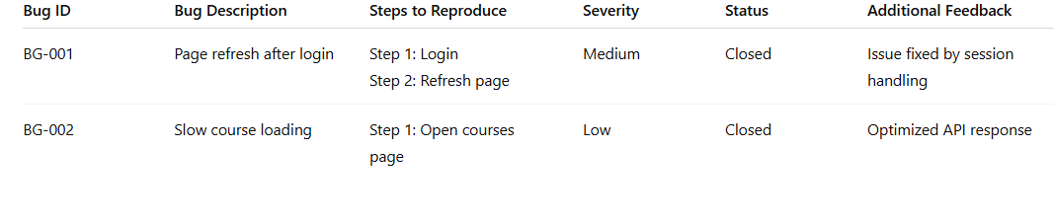Notes:
• All major functional requirements have been tested successfully.
• Both positive and negative scenarios were validated.
• Minor bugs identified during testing were resolved.
• The application is ready for deployment after successful UAT sign-off.

